<https://www.youtube.com/playlist?list=PLKueo-cldy_HjRnPUL4G3pWHS7FREAizF>

Git Playlist

<https://www.typescriptlang.org/docs/handbook/classes.html>

Typescript Handbooks Assignments Programmings Animals Etc

<https://github.com/junaidsheikh02/45-Assignments-Typescripts-Only>

45 Assignments

<https://github.com/panaverse/learn-typescript>

Classes Assignments//

<https://github.com/panaverse/learn-typescript/tree/master/step09f_function_overloads//>

<https://chat.openai.com/>

junaid01@@@$$$

[junaidulhaquesheikh02@gmail.com](mailto:junaidulhaquesheikh02@gmail.com)

<https://github.com/junaidsheikh02/45-Assignments-Typescripts-Only>

<https://github.com/junaidsheikh02/45-Assignments-Typescripts-Only/blob/main/main.js>

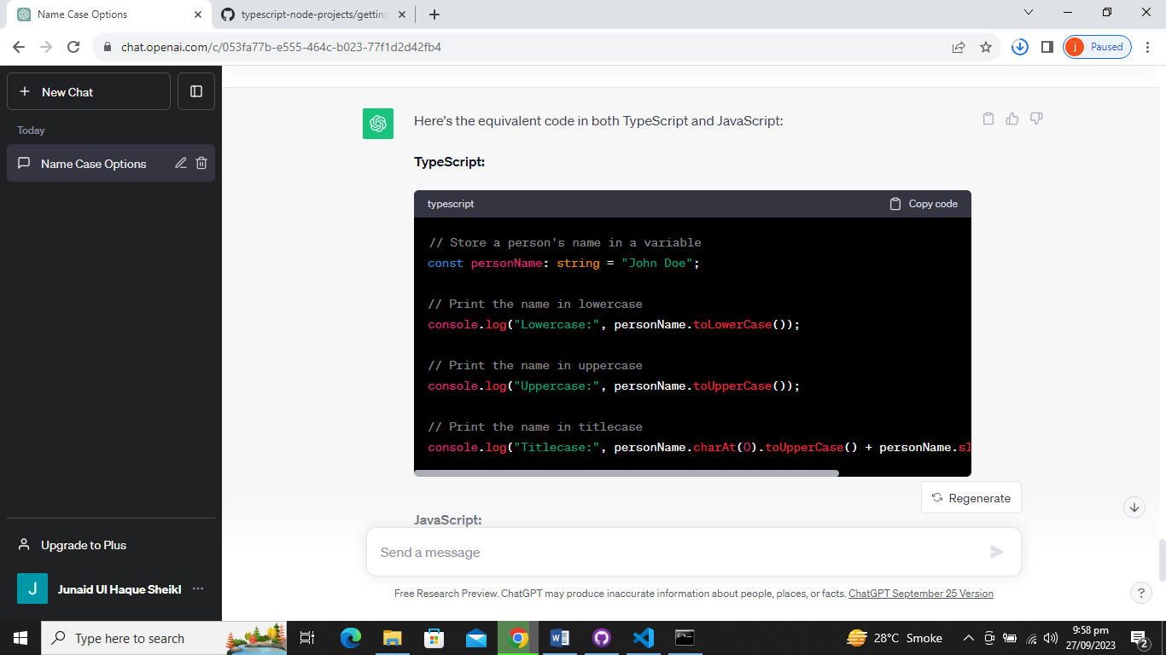

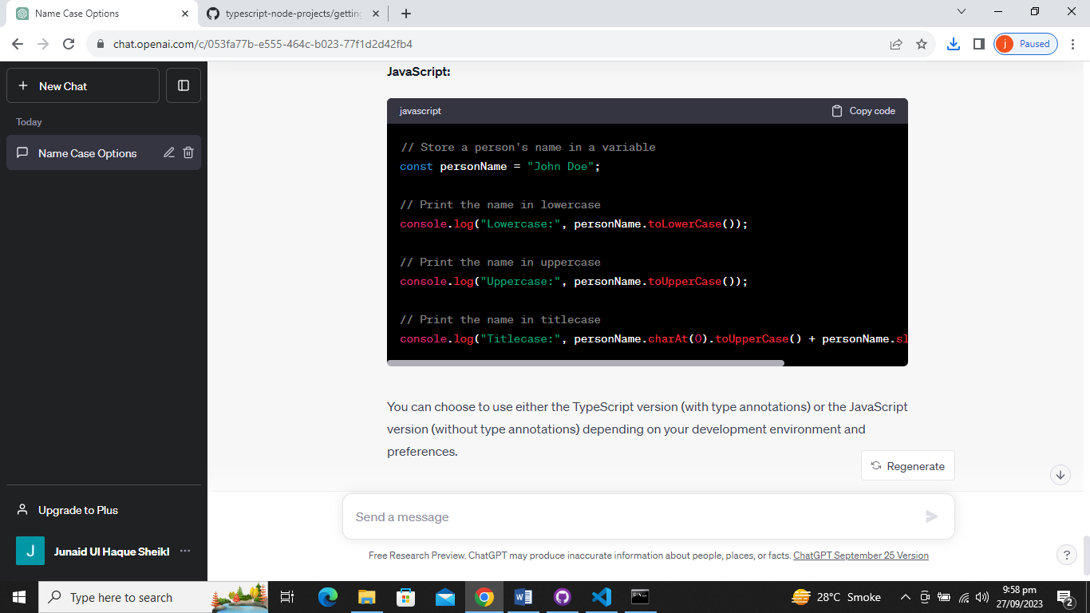

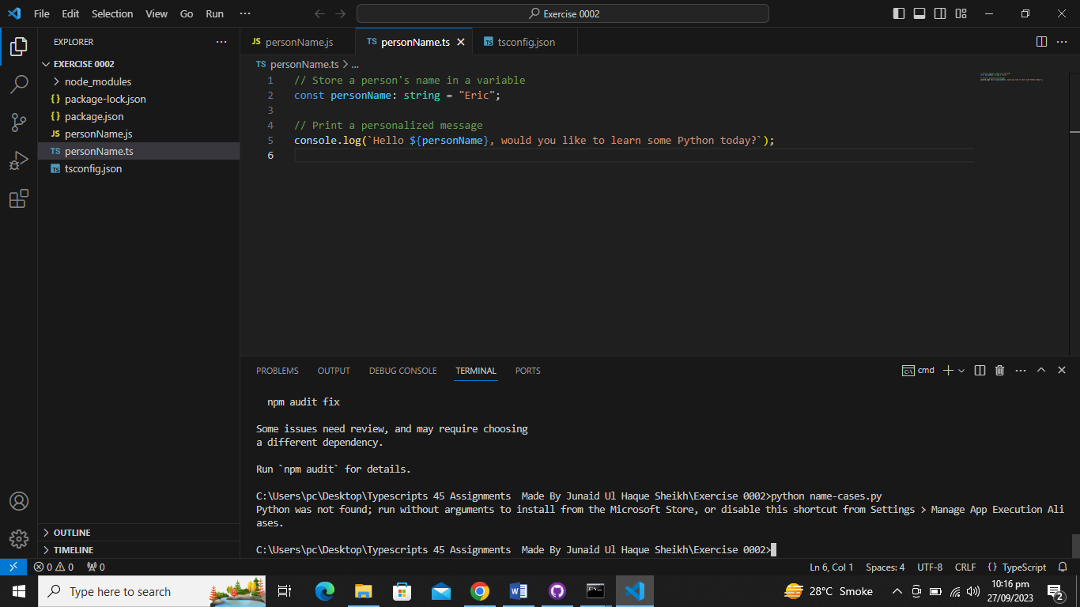

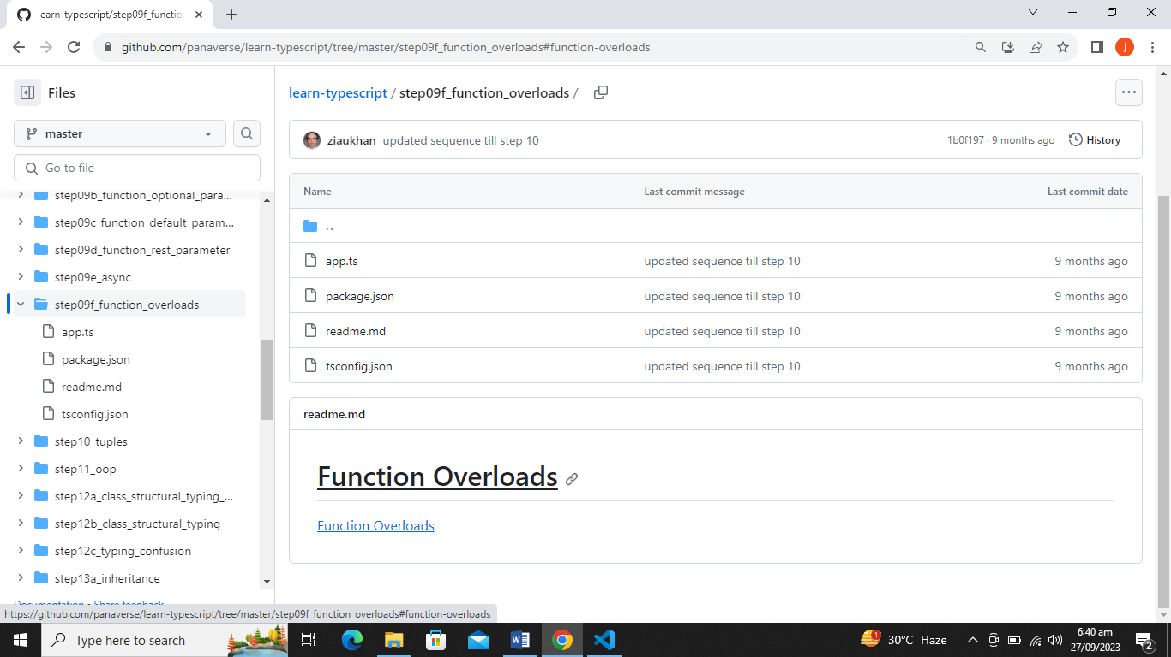

step09f_function_overloads

Today Classes //Wednesday//27/09/2023



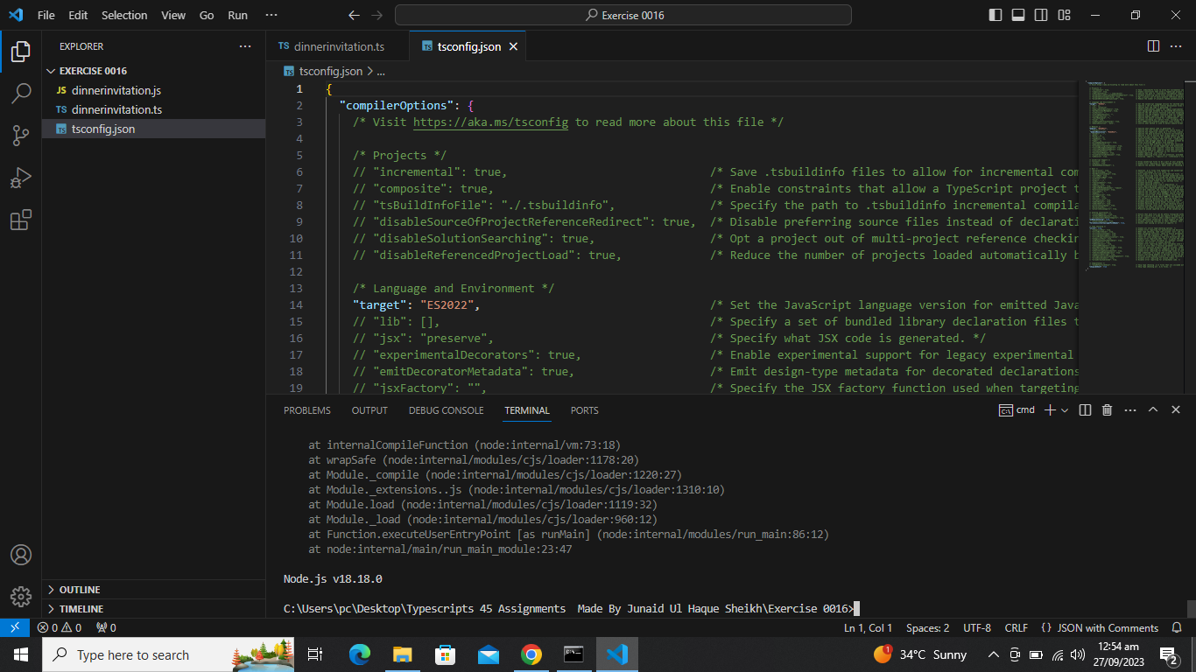

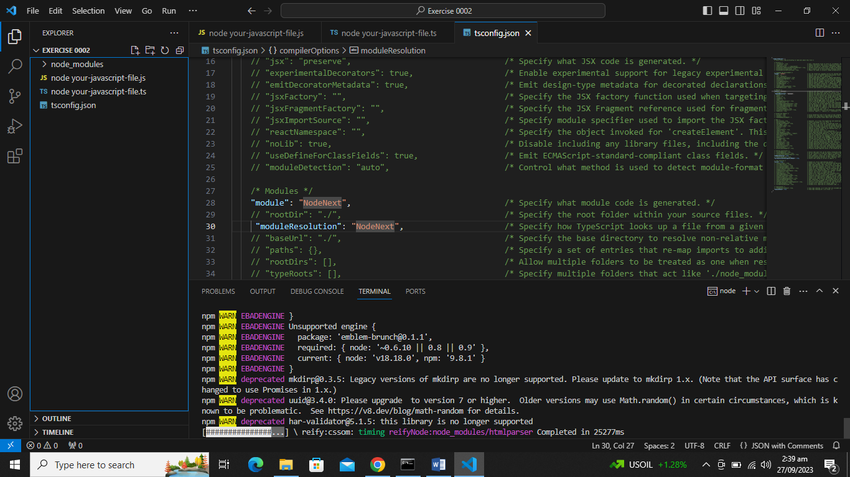

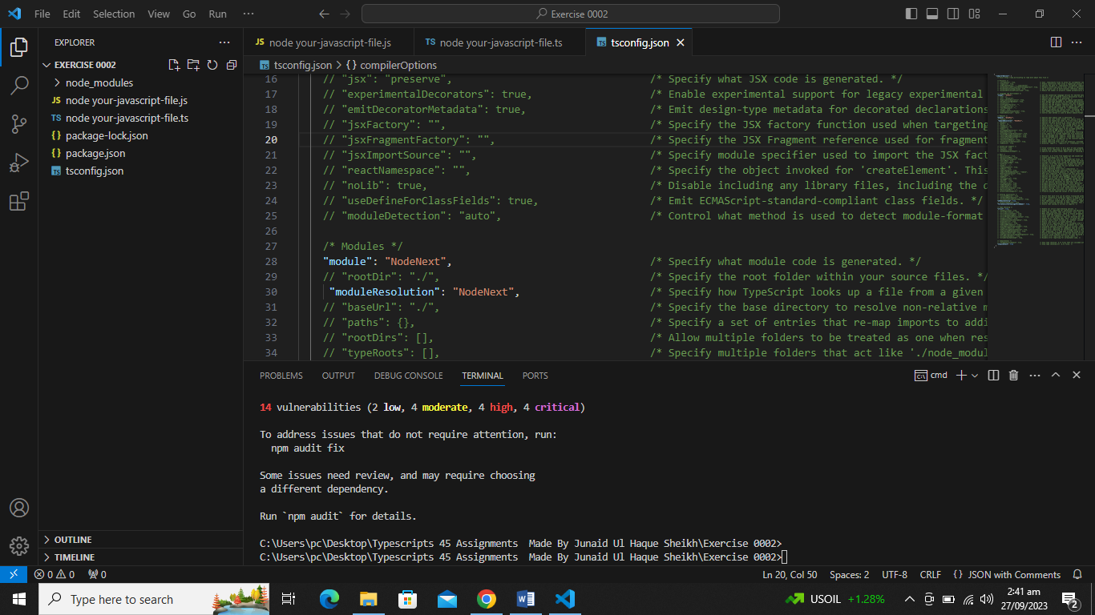Function Overload Class 10 // Overloading // Overloading Kya Hote Hain ????//Wednesday//String Pass Karatain//Kuch Bhe Return Kar sakta Hain//Return Main Number Ayega Yahan String//

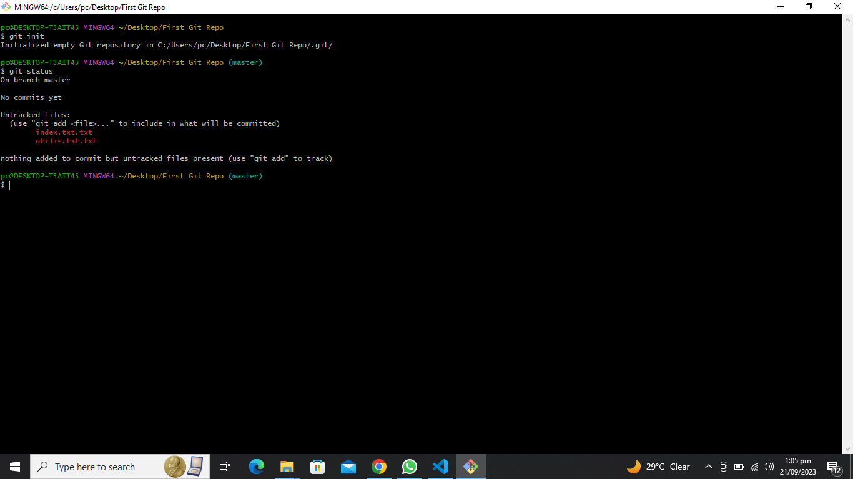

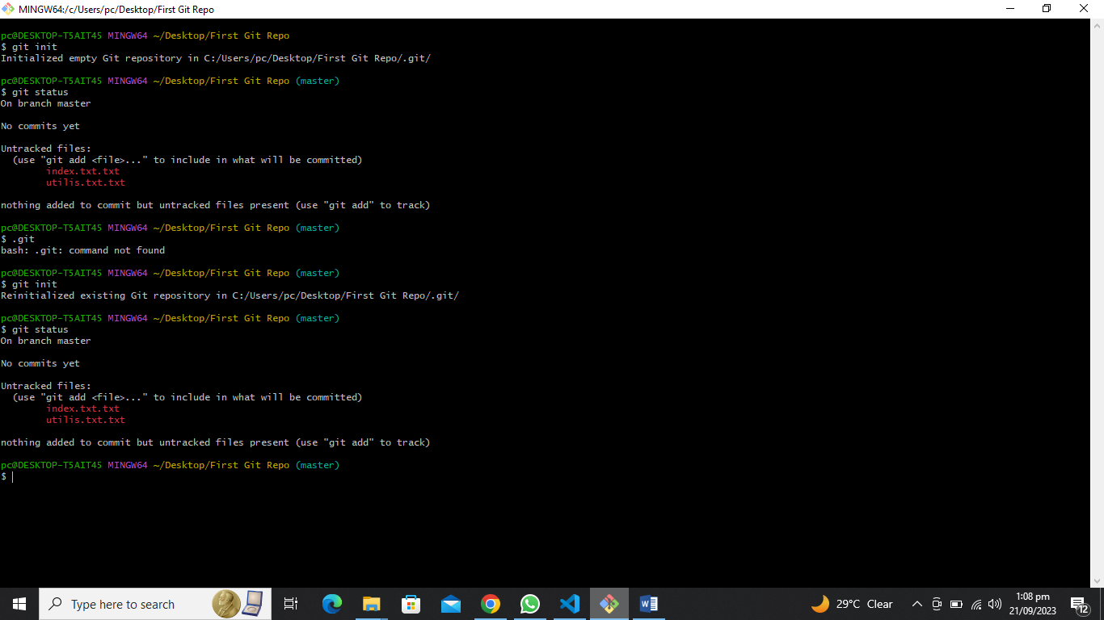

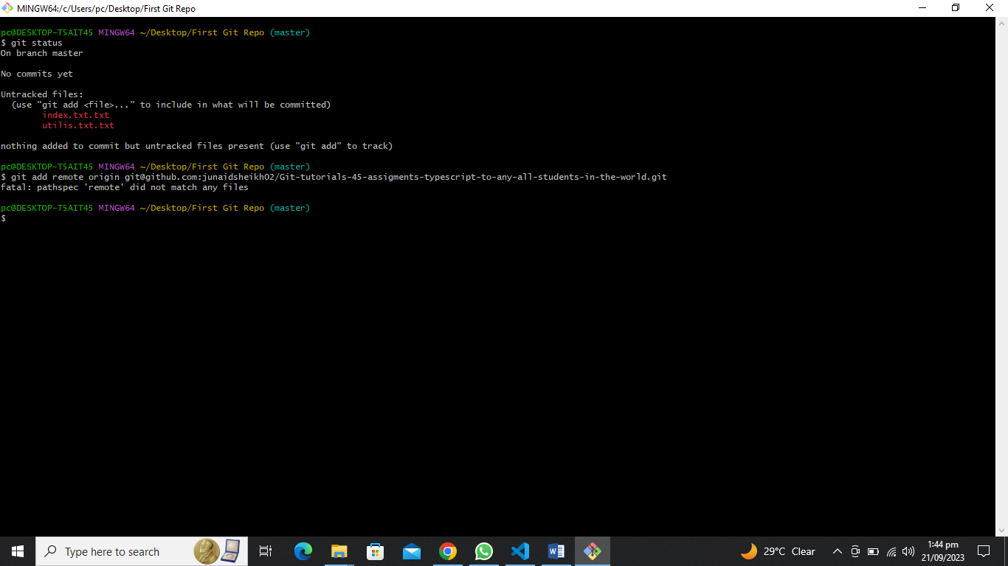

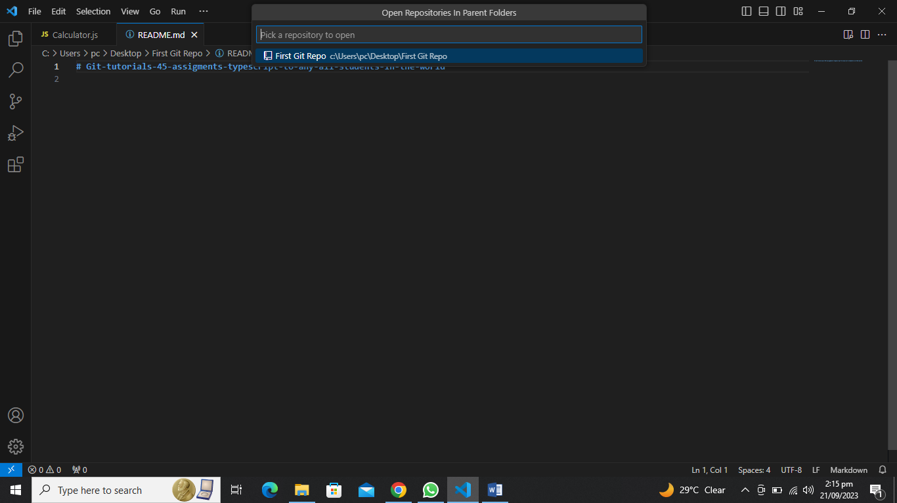

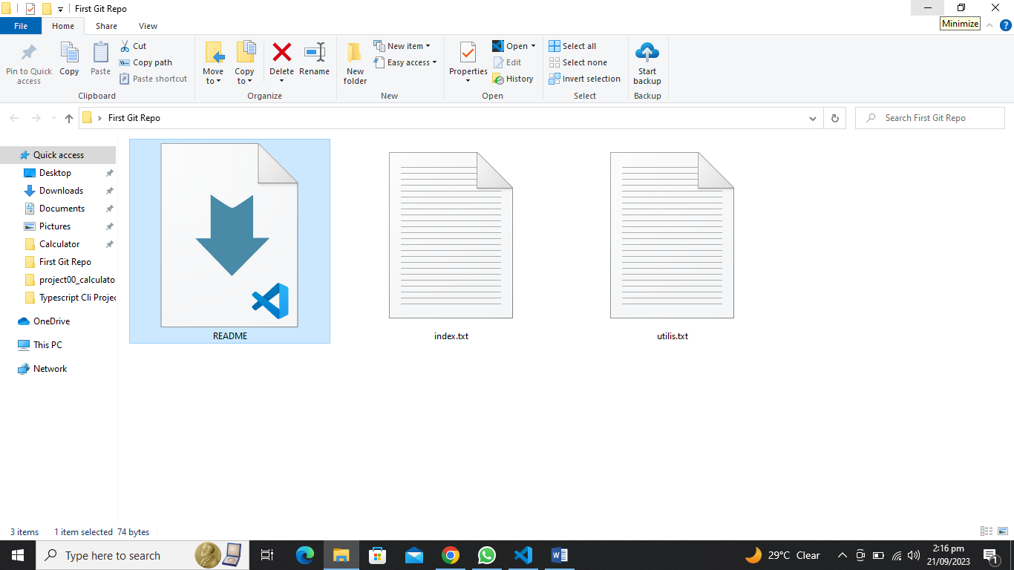

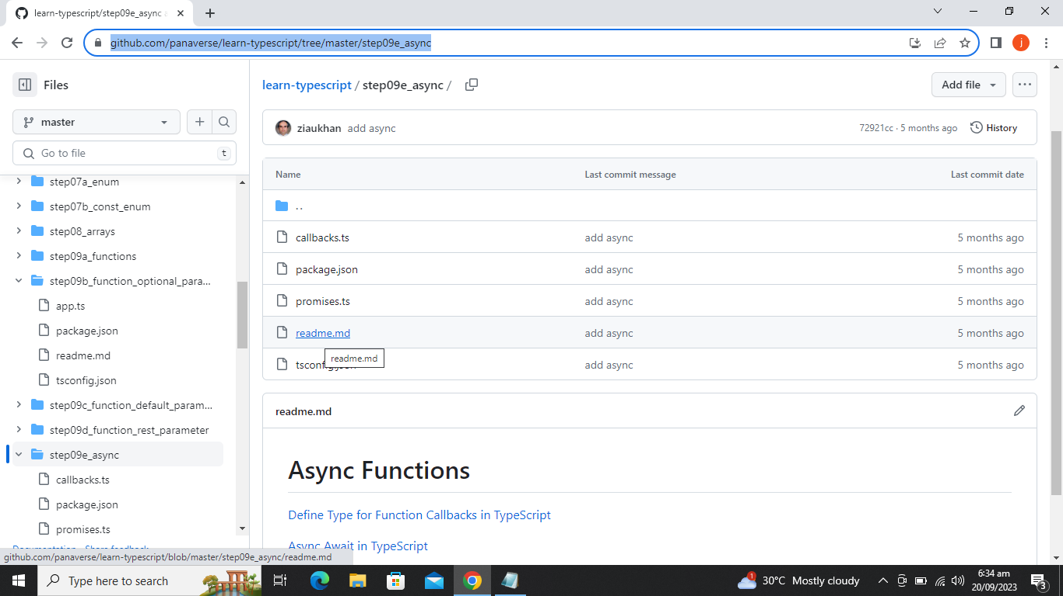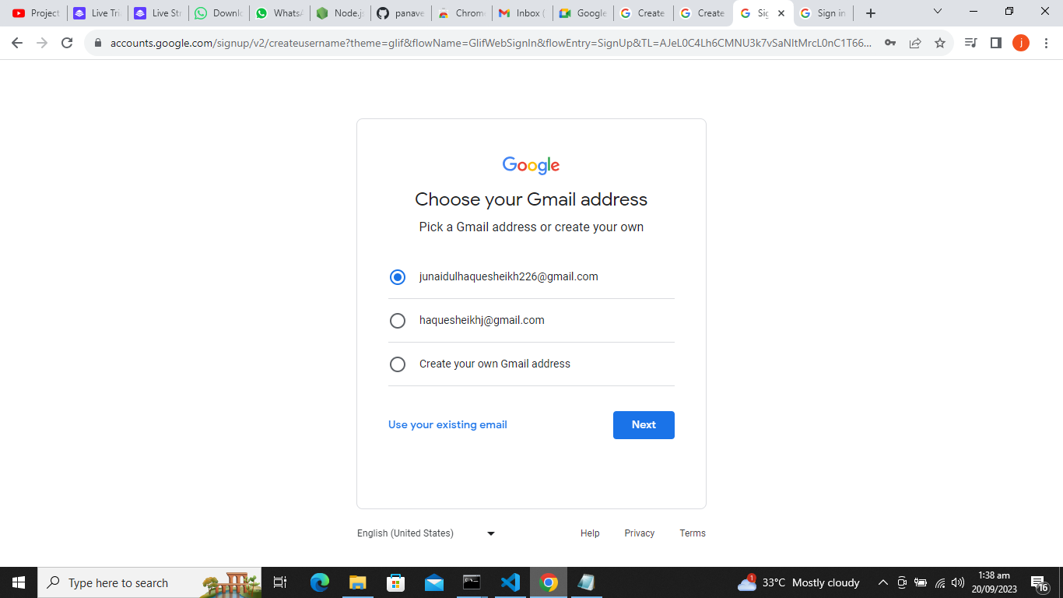

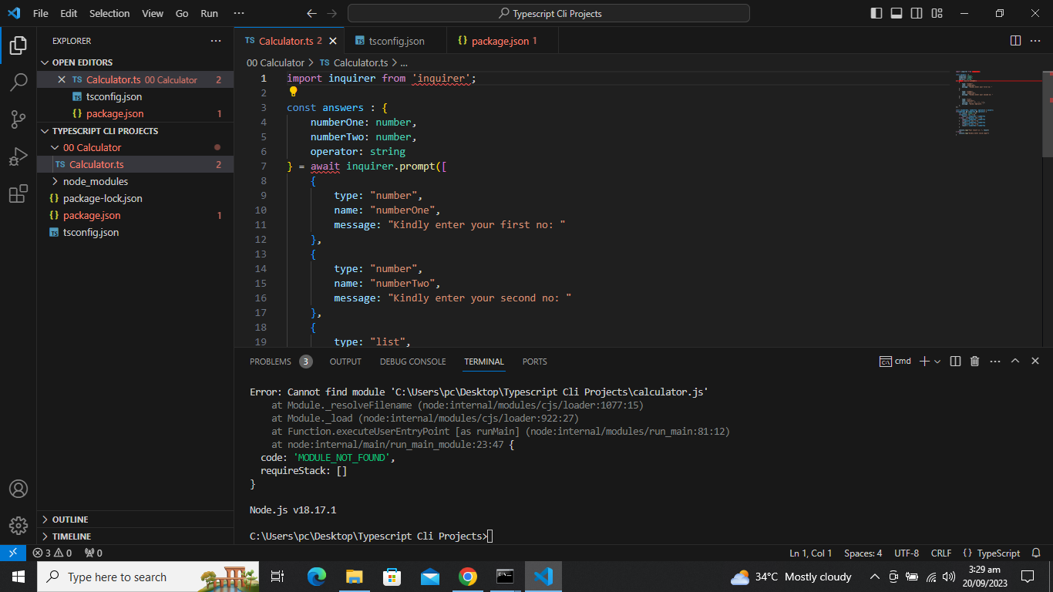

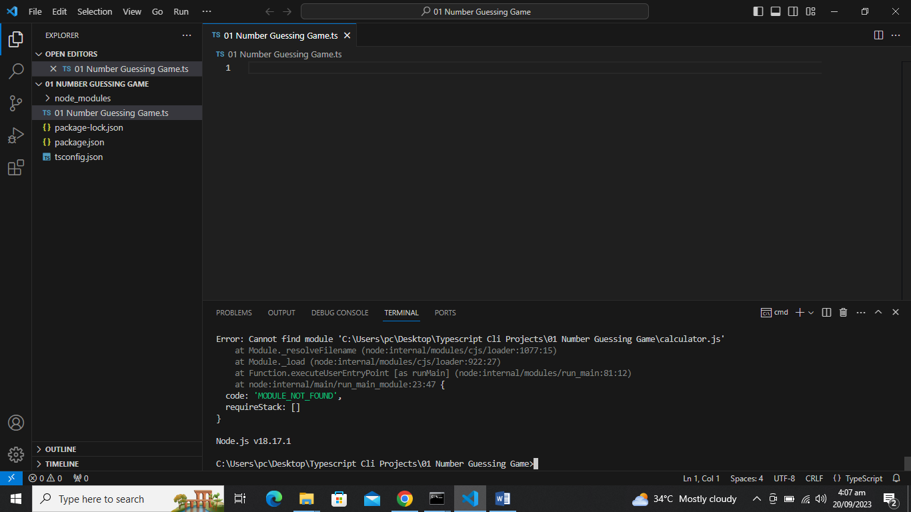

junaid01@@@$$$

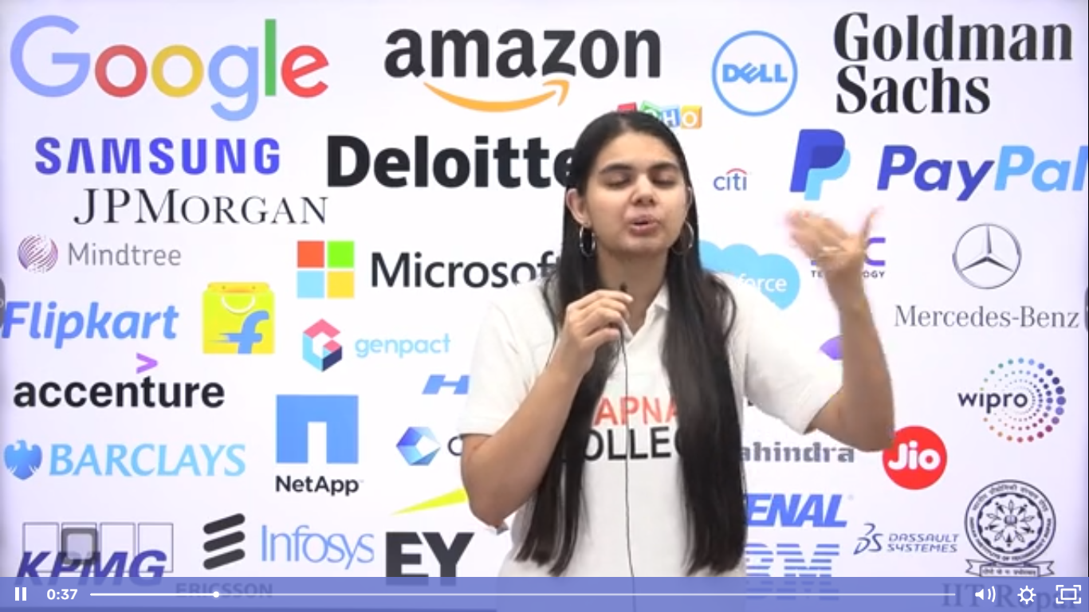

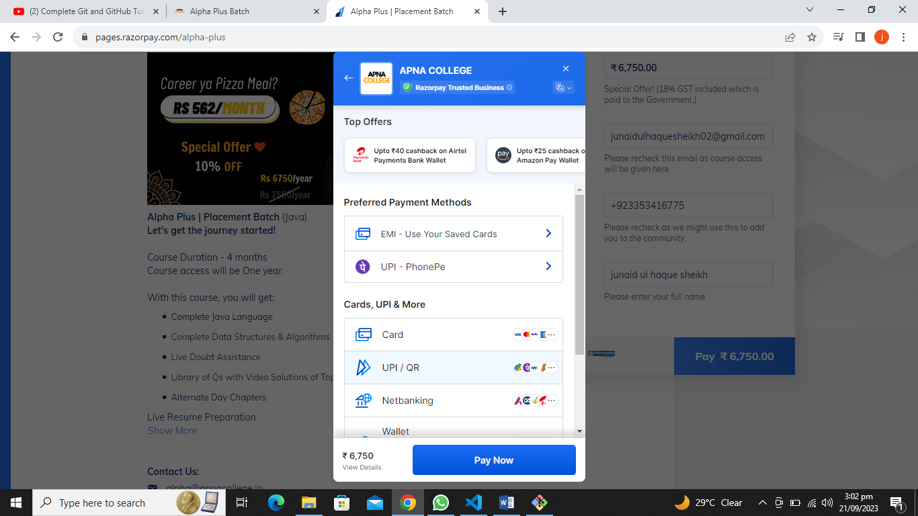

SSID: Infinix HOT 4

Protocol: Wi-Fi 4 (802.11n)

Security type: WPA2-Personal

Network band: 2.4 GHz

Network channel: 6

Link speed (Receive/Transmit): 65/65 (Mbps)

Link-local IPv6 address: fe80::93cf:9dca:6d1:eeee%21

IPv4 address: 192.168.43.203

IPv4 DNS servers: 192.168.43.1

Manufacturer: Intel Corporation

Description: Intel(R) Dual Band Wireless-AC 7265

Driver version: 19.51.24.3

Physical address (MAC): B6-14-AC-9D-FA-E3